Civil war in [Rwanda]

UNSC Resolution: | 1029
Date of adoption: | 12-December-1995
Operative paragraph: | 9
Demand number: | 1029.0911

[Philippe Rieder]

Wording of demand
Continue take all necessary measures to ensure that UNAMIR personnel and equipment that are scheduled to withdraw can do so in an orderly and safe manner

List of addressees of the demand
Government of Rwanda

Short-term compliance

Description of the addressee(s)’ conduct

“885. Pursuant to the request of the Government and Security Council resolution 1029 (1995) of 12 December, the United Nations Assistance Mission for Rwanda (UNAMIR) was reduced and then withdrew from the country following the expiry of its mandate on 8 March 1996. Pursuant to General Assembly resolution 50/58 L of 22 December 1995, I began consultations with the Government and relevant United Nations agencies on the nature and role of a continued United Nations presence in Rwanda in the post-UNAMIR period.” (Report of the Secretary-General on the work of the organization, (A/51/1), 20 August 1996, p. 124)

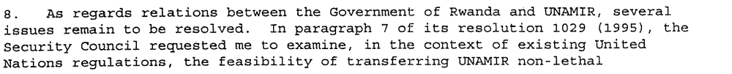
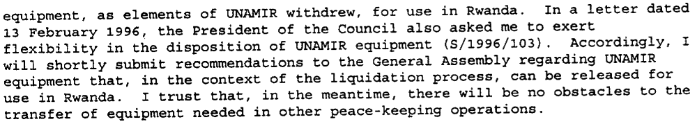
(Progress Report of the Secretary-General on UNAMIR (S/1996/149), 29 February 1996, p. 2f)
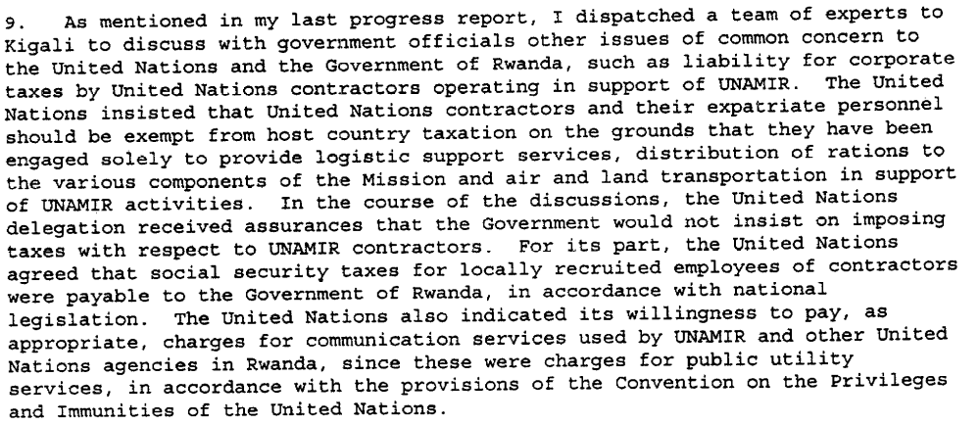
(Progress Report of the Secretary-General on UNAMIR (S/1996/149), 29 February 1996, p. 3)
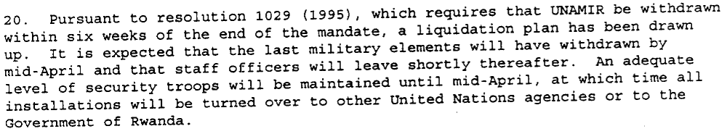
(Progress Report of the Secretary-General on UNAMIR (S/1996/149), 29 February 1996, p. 5)
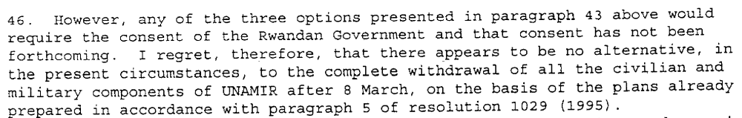
(Progress Report of the Secretary-General on UNAMIR (S/1996/149), 29 February 1996, p. 11)

“886. Occasional differences cropped up between UNAMIR and the Government, although relations continued to be generally good during the final three months of the mandate. The disposition of UNAMIR equipment and assets was a case in this point; so was the Government’s insistence that contractors providing goods and services for the exclusive use of UNAMIR should pay various types of taxes. (...)
With regard to the disposition of UNAMIR equipment, the Government, after inspecting the various items, decided to accept them. However the tax dispute could not be resolved.
887. In his consultations with the Rwandan authorities, the Under-Secretary-General recalled that the Security Council had welcomed the letter from the Foreign Minister of Rwanda of 1st March, which described the functions the Government wished the United Nations to perform following the departure of UNAMIR and recorded its acceptance of the maintenance of a United Nations office in Rwanda.” (Report of the Secretary-General on the work of the organization, (A/51/1), 20 August 1996, p. 124)

“5. Detailed plans for the withdrawal of the UNAMIR military personnel have been drawn up and are being implemented. As of 12 April 1996, a total of 679 personnel, comprising 11 military observers, 648 troops and 20 headquarters staff remained in Rwanda. It is expected that their withdrawal will be completed between 12 and 19 April.” (Report of the Secretary-General on the implementation of resolution 1050 (1996) concerning the withdrawal of UNAMIR, (S/1996/286), 15 April 1996, p. 1)

“8. The International Tribunal for Rwanda and the Government have reached an agreement on the rental of the Amahoro Hotel, the current UNAMIR headquarters, which is to be taken over by the Tribunal following the departure of UNAMIR. The Tribunal will take over responsibility for the operation and maintenance of the UNAMIR communications system and provide the communications needs of all other United Nations agencies in Rwanda that formerly relied on UNAMIR for this purpose.”
(Report of the Secretary-General on the implementation of resolution 1050 (1996) concerning the withdrawal of UNAMIR, (S/1996/286), 15 April 1996, p. 1)

“To ensure the smooth running of the Human Rights Field Operation in Rwanda after the withdrawal of UNAMIR [completed 19 April 1996], it is essential that the Government of Rwanda continue to cooperate and provide information and adequate security to the field teams. (…)
28 I had hoped to be able to report to the Security Council that agreement had been reached with the Government of Rwanda on the establishment of UNOR and that there could therefore be a smooth transition from UNAMIR to the new office when the formers funding expires on 19 April 1996. Unfortunately, this is not the case. In spite of intensive efforts of my Special Representative, it has not yet been possible to confirm the Government’s acceptance of the mandate described in paragraph 4 of resolution 1050 (1996), on which the Government is still seeking “clarifications”. Nor has the Government yet confirmed its agreement that the United Nations should continue to operate a radio station in Rwanda.” (Report of the Secretary-General on the implementation of resolution 1050 (1996) concerning the withdrawal of UNAMIR, (S/1996/286), 15 April 1996, p. 3f)

“30. As called for in paragraph 3 of resolution 1050 (1996), I trust the Government of Rwanda will take the necessary measures to ensure that UNAMIR personnel and equipment can be withdrawn without impediment in an orderly and save manner.”
(Report of the Secretary-General on the implementation of resolution 1050 (1996) concerning the withdrawal of UNAMIR, (S/1996/286), 15 April 1996, p. 4)

“UNAMIR's mandate came to an end on 8 March 1996. The withdrawal of the Mission was completed in April” (Department of Public Information, United Nations, 31 August 1996, in: http://www.un.org/Depts/DPKO/Missions/unamir_p.htm(17 September 2009))

“12. Unfortunately, it did not prove possible to resolve the outstanding disagreement between the Unitde Nations and the Government on the latter’s claim for taxes against corporations that had come into the country as contractors to UNAMIR. President Bizimungu and the Under-Secretary-General concluded at their meeting on 23 April that the two sides would have to agree to disagree on this matter.
13. It is a matter of satisfaction that agreement has been reached with the Government on the establishment of a United Nations office in Rwanda.” (Addendum to the report of the Secretary-General on the implementation of resolution 1050 (1996) concerning the mission of the Under-Secretary-General for Political Affairs to Rwanda, (S/1996/286/Add.1), 3 May 1996, p. 3)

“When the UNAMIR forces departed from Rwanda in September 1995 they had left behind over two hundred vehicles in running order as a “gift to the people of Rwanda”. These included sixty-four troop carriers, which had of course been snapped by the RPA and which were used in the Gatumba invasion.” (Gerard Prunier describing the start of the fighting in the Kivus in July 1996, in: Africa’s World War, Oxford 2008, p. 70)

Assessment

Short-term compliance
No or marginal compliance (1) | Medium low compliance (2) | X Medium high compliance (3) | Full or almost full compliance (4)

Considerations underlying the assessment

Apart from occasional differences between UNAMIR and the Government, especially regarding taxes, the relations continued to be generally good during the final three months of the mandate.

Medium-term compliance

Description of the addressee(s)’ conduct

The withdrawal of the Mission was completed in April 1996.

Assessment

Medium-term compliance
No or marginal compliance (1) | Medium low compliance (2) | Medium high compliance (3) | Full or almost full compliance (4)

Considerations underlying the assessment

Depth of Demand

Assessment

Level of depth of demand
X Low depth of demand (1) | Medium depth of demand (2) | High depth of demand (3)

Considerations underlying the assessment

Level of confidence about coding decisions

Level of confidence about coding decision
Extremely high | X High | Moderate

Comments to IPI (if any)

